Drilling Underway at Lucky Break Gold Mine

- 1,500m of reverse circulation (RC) drill program has commenced

- Drilling under the pit floor to assess potential mineralisation at depth and testing some mineralised shoots down dip of the previously mined gold deposit

- Also testing under the Luck Break South pit which was previously mined as a small high-grade deposit

- Testing the extensions to the North and the South of the historical pit and a parallel vein to the east of the main Lucky Break mineralised zone
22 April 2021: QX Resources Limited (ASX: QXR, “QX” or “the Company”) is pleased to confirm that a 1,500m reverse circulation (RC) drill program at the Company’s Lucky Break gold mine located at the Clermont Goldfields in the Drummond Basin of central Queensland commenced yesterday (see Figure 1 of drill rig on site).
This first pass drill program has been designed to assess mineralisation in two historical pits – the main Lucky Break Mine and the small Lucky Break South pit which was previously mined as a small high-grade deposit – as well as extensions to these mines along strike and at depth. As well, a parallel vein to the East of the main deposit is being drilled (See image 2 overleaf and refer to the ASX update of 9 April 2021 for more detailed geological information on Lucky Break).
Drilling is expected to take ~10 days and assaying will commence shortly thereafter. The Company will provide updates on the progress of the drill program in the coming days.

Non-Executive Director Roger Jackson said, “After extensive planning and detailed analysis of all historical data over many months, we are pleased to kick off this first pass, high impact drill program that is testing some exciting targets in and around the historical Lucky Break Mine pits. Limited exploration at depth, along strike and parallel to the actual mines has been conducted so we look forward to assessing the results. The program is expected to take approximately ten days and it marks the first step in QX significantly ramping up exploration activities across our wider ~150km² project area that hosts multiple highly prospective mineralised targets with a range of commodities present. We look forward to reporting results from this program and on our other exploration and project development initiatives.”

Figure 1: Drilling underway at Lucky Break.

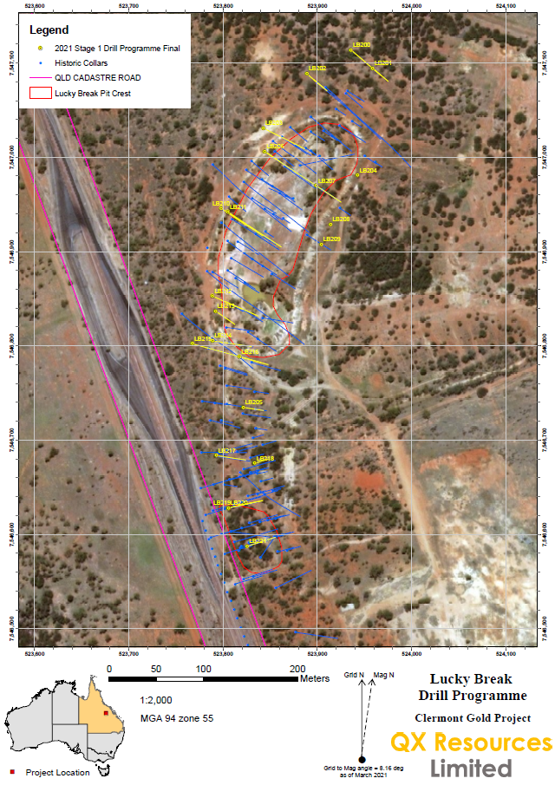
Figure 2: Proposed drill holes (yellow) for 1,500m drill program currently underway.

Competent Person’s Statement

The information in this report that relates to the Ibis project is based on information compiled by Mr. Roger Jackson, a Director and Shareholder of the Company, who is a 25+ year Fellow of the Australasian Institute of Mining and Metallurgy (MAusIMM) and a Member of Australian Institute of Company Directors. Mr. Jackson has sufficient experience which is relevant to the style of mineralisation and type of deposits under consideration and to the activity which he is undertaking to qualify as a Competent Person as defined in the 2012 Edition of the “Australasian Code for Reporting of Exploration results, Mineral Resources and Ore Reserves”. Mr. Jackson consents to the inclusion of the data contained in relevant resource reports used for this announcement as well as the matters, form and context in which the relevant data appears.

This announcement was authorised for release by the Board of QX Resources Limited.

Further information:

Maurice Feilich, Executive Chairman: Ph: 0411 545 262

Roger Jackson, Non-Executive Director: Ph: 0400 408 550

Forward Looking Statements and Important Notice
This report contains forecasts, projections and forward-looking information. Although the Company believes that its expectations, estimates and forecast outcomes are based on reasonable assumptions it can give no assurance that these will be achieved. Expectations and estimates and projections and information provided by the Company are not a guarantee of future performance and involve unknown risks and uncertainties, many of which are out of QX Resources’ control.
Actual results and developments will almost certainly differ materially from those expressed or implied. QX Resources has not audited or investigated the accuracy or completeness of the information, statements and opinions contained in this announcement. To the maximum extent permitted by applicable laws, QX Resources makes no representation and can give no assurance, guarantee or warranty, express or implied, as to, and takes no responsibility and assumes no liability for the authenticity, validity, accuracy, suitability or completeness of, or any errors in or omission from, any information, statement or opinion contained in this report and without prejudice, to the generality of the foregoing, the achievement or accuracy of any forecasts, projections or other forward looking information contained or referred to in this report.

Investors should make and rely upon their own enquiries before deciding to acquire or deal in the Company’s securities

